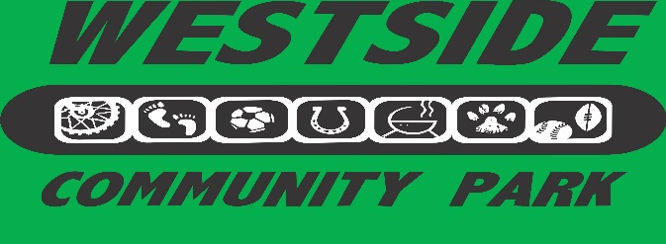

1401 Charlie Jolin Way Lakeport, California
www.westsidecommunitypark.org

WESTSIDE COMMUNITY PARK COMMITTEE Tax # 68-0415643
Mailing Address: 1350 Berry Street, Lakeport, CA 95453
Grillin’ on the Green Competitor Application
Barbeque Cook-off, 5-7:30 pm
Saturday, August 7, 2021
Team Name______________________________________________________
Organization Affiliation (circle one): Community Service Organization, Public Employees (law enforcement, fire protection), Business Associations, Professional, and Open Entry
Barbeque (circle one): BEEF, CHICKEN, PORK, FISH
Chief Cook _______________________________________________________
Address _________________________________________________________
Telephone __________________ E-Mail ______________________________
No entry fee required. Competitors will provide all necessary food, ice and barbequing supplies. Your contribution to Westside Community Park is your participation in this event. Thank you. Donations through participation in Grillin’ on the Green are tax deductible.
One 20’ x 20’ space is included. Limited parking nearby will be available.
COOKING METHOD: (Circle 1 or more) GAS / CHARCOAL / PELLET / WOOD (No electricity available on site)
Four cook armbands come with registration.
By signing this form I agree to indemnify and hold the City of Lakeport, Westside Community Park Committee, co-sponsors, agents, employees and volunteers harmless from any and all claims including without limitation, all costs, liabilities, judgments, expenses, damages, or reasonable attorney fees arising out of or in connection with: 1) any structure erected by contestant; 2) any apparatus, equipment, or personal property used by contestant; 3) any act of omission on the part of contestant, its agents, invitees, participants, representatives, employees, servants and agents; 4) any claims made on account or arising from or out of the Contestants participation in this fundraising event.
Chief Cook’s Signature _____________________________________________
DEADLINE: July 16, 2021
I will serve 300 (1 -2 oz.) servings on Saturday, August 7, 2021 from 5 pm – 7:30 pm.
- All contestants will participate in the People’s Choice Competition and Celebrity’s Choice Competition. First year participants will be eligible for Rookie of the Year. Prizes will consist of engraved trophies for the winners.
- Participation for the Best Decorated Booth is optional. A trophy will be given for the winner of this competition
- Applicants will be sent a complete event packet upon receipt of this application.

Mail entry form to Cindy Ustrud / Dennis Rollins, 1350 Berry St., Lakeport, CA 95453
Entry form available online by emailing your request to cindyu52@sbcglobal.net

