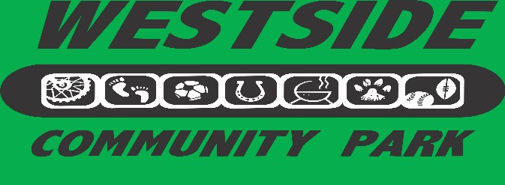

1401 Charlie Jolin Way Lakeport, California
www.westsidecommunitypark.org
WESTSIDE COMMUNITY PARK COMMITTEE Tax # 68-0415643
Mailing Address: 1350 Berry Street, Lakeport, CA 95453

June 2021
Dear Grillin’ on the Green Past and Potential Participants,
Westside Community Park Committee is sponsoring its eleventh annual Grillin’ on the Green, a fundraising barbeque cook-off event and competition on August 7, 2021. We want to thank those of you who participated in previous years and hope you will join us again for a fun event. We also thank those organizations and businesses who gave their support through sponsorships.
All funds raised from Grillin’ on the Green go to the development of Westside Community Park, a City of Lakeport recreational facility. Thanks to the ongoing support and numerous contributions of volunteers, local businesses, and service organizations, youth and adult baseball, softball, and soccer leagues use Westside Community Park for practice fields and games. There also are horseshoe pits built by the Early Lake Lions and a league that plays there weekly. To be completed is the extension of the walking trail that will follow the perimeter of the entire park. Plans for the development of a Horse Park, Lakeport Lions Playground and the Marla Ruzicka Futsal court continue to be a focus and are in development. Future projects include paving of the Jane Barnes parking lot and then beginning of Phase 3 of the park. In total there are over 60 acres dedicated for the park. To date only 12-15 acres have been in development not including the horse park.
Grillin’ on the Green is a family oriented barbeque cook-off. It is our goal to have 12-15 barbeque stations that will each serve approximately 300 (1-2 oz) tastings to event attendees. We will have our annual People’s Choice Award with tasters voting for their favorite sampling, and the Celebrity’s Choice and Rookie Griller Awards for the tastiest barbeques determined by three local celebrities. There is a People’s Choice Award for best Booth Theme for those groups who choose (optional) to decorate their tasting station. Each griller may choose their own theme.
It will be the responsibility of each barbeque group to provide their choice of beef, chicken, pork or fish and all the necessary equipment and supplies to set up a barbeque station. All groups must serve food that meets Lake County Health Department standards. Cindy Ustrud will assist each participant with meeting those requirements
Additional fund raising opportunities will be beer and wine sales. There will be live music entertainment. Children’s activities will round out the event. Local car clubs will be displaying their vehicles.
Tickets go on sale in June. Pre-sale Adult tickets are $25.00, children 12 and under are $10.00, and no charge for children 4 and under. Tickets sold at the event will be $30.00 with children’s prices remaining at $10.00.
The Westside Community Park Committee recognizes that you receive requests for donations on a continuous basis and every cause is a worthy one. It is our sincere desire that you will choose to participate in this fun event. If your group is not able to participate as a Griller we have added the opportunity for you to sponsor a Grillin’ participant at the rate of $500.00. Please contact Cindy Ustrud for details.
Attached are an informational flyer and entry form for the Grillin’ on the Green event and competition. Entries are due Friday, July 16, 2021. Please call Cindy Ustrud, 263-7091 with your questions. The committee looks forward to working with you.

Sincerely,

Peggy Alexander, Michelle Figg, Beth Havrilla, Alice Holmes, Carol Maxwell, Dennis Rollins, Val Schweifler, Wilda Shock, Cindy Ustrud
Westside Community Park Fundraising Committee Member

